ACS-2814: Applications Of Database Systems
Lab 6

Daljeet Singh, 3169763

Part A: Preparing Table Properties for Form Development [ 3 marks ]
Place screenshots of the key steps in the table below

Question/Step | Screenshot (paste below, adjacent to each question)
Screenshot 1: County Drop Down | 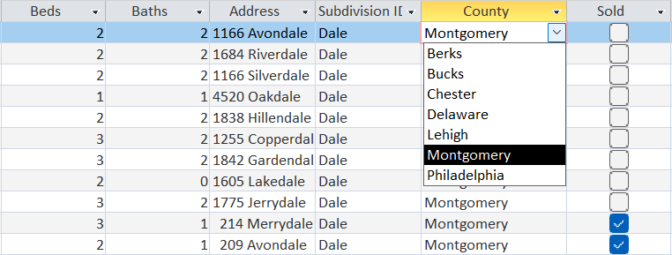
Screenshot 2: Beds Drop Down | 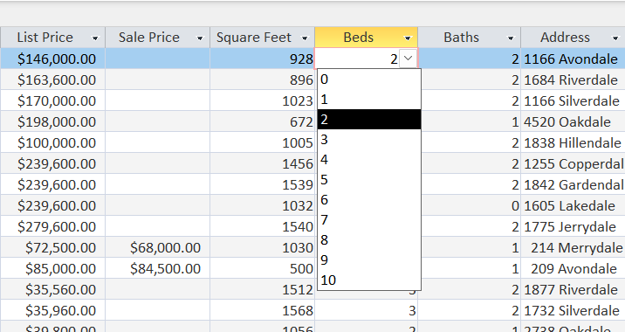
Screenshot 3: Baths Drop Down | 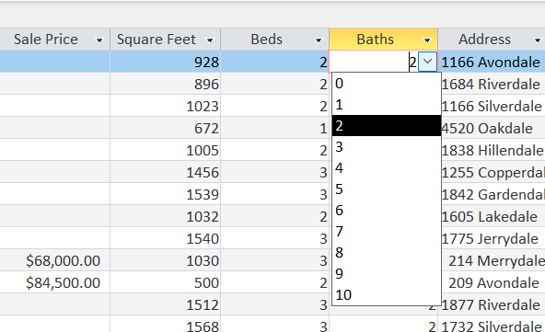

Part B: Building a Two-Table Form and Improving Layout/Appearance

[12 marks]
Place screenshots of the key steps in the table below

Question/Step | Screenshot (paste below, adjacent to each question)
Screenshot 4: Listing # 10025 (record #25) showing the Listing Tab and Extras | 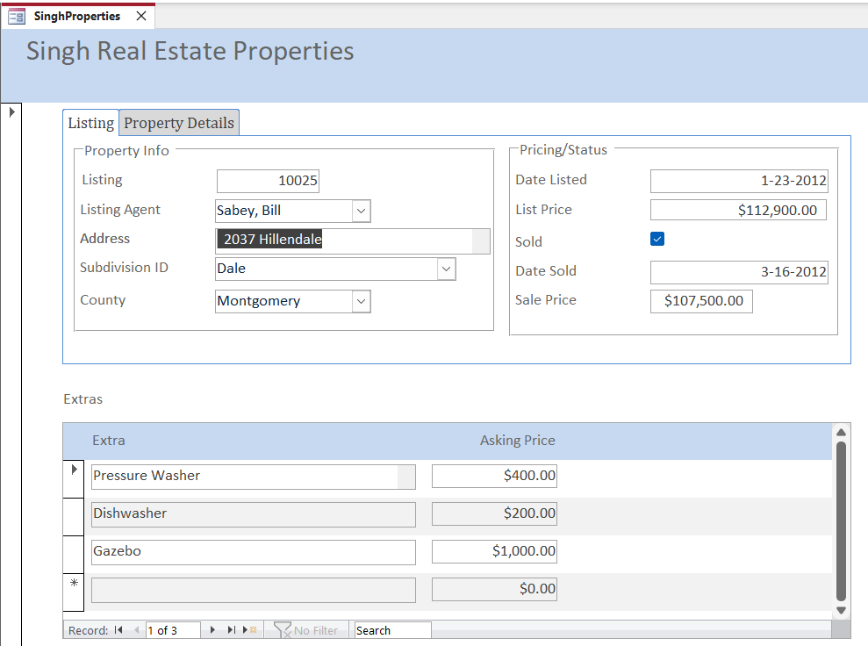
Screenshot 5: : Listing # 10025 (record #25) showing the Property Details Tab | 